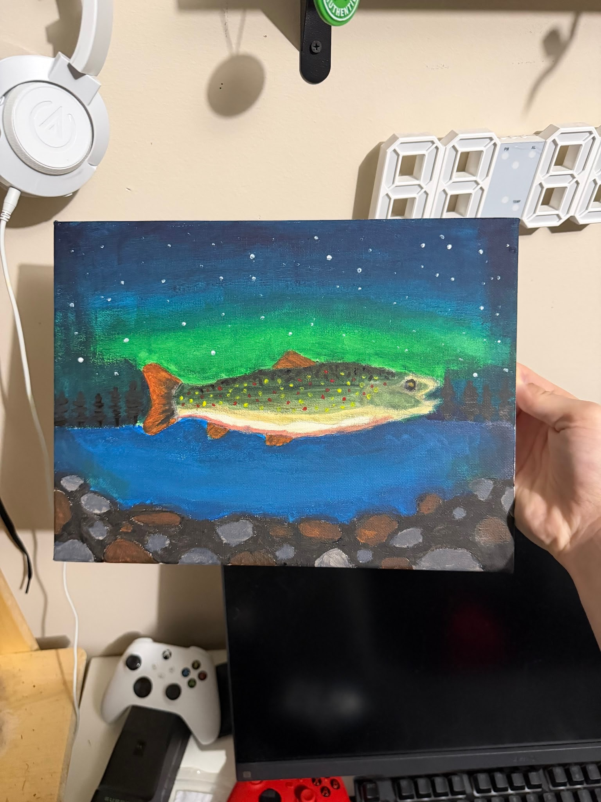

https://www.nathab.com/blog/fifteen-native-tales-about-the-northern-lights

https://uinr.ca/wp-content/uploads/2013/07/Salmon-MEK-WEB.pdf

My painting is based off of many images I've seen online, and northern lights, and brook trout significance in the Mi’kmaq culture. I saw pictures of what I wanted to recreate from my links and google, and recreated it in my own way.

